Insta Mechanic — Step‑by‑Step Roadmap
A practical, developer‑friendly plan to build a working web MVP of Insta Mechanic using HTML/CSS/ Bootstrap for the frontend and a simple Node.js/Express + PostgreSQL backend. You can present this as your execution plan to your HOD and follow it while building.
🎯

Goals & Scope
- Goal: Let a user book a nearby, verified mechanic; let a mechanic accept jobs; allow admins to verify mechanics and monitor bookings.
- Primary platform: Responsive website (Bootstrap 5). Mobile‑first layouts.
- MVP city: Start with one city/area.
- Success metric (MVP): A user can complete a booking with payment captured and receive confirmation; a mechanic can accept & mark job complete.

🧱 Tech Stack (Recommended)
- Frontend: HTML5, CSS3, Bootstrap 5 (via CDN), vanilla JS (or Alpine.js)
- Backend: Node.js + Express (REST API)
- Database: PostgreSQL (with Prisma ORM or Sequelize)
- Realtime: Socket.io (for live status/location), optional in Phase 6
- Payments: Razorpay (IN) or Stripe (global)
- Auth: Email/phone + password (JWT); OTP optional later
- Hosting: Frontend on Netlify/Vercel; Backend on Render/Railway/Heroku; DB on Railway/Supabase

🗺️ Phased Roadmap (Step‑by‑Step)

Phase 0 — Plan & Design (1–2 days)
- Define personas: Customer, Mechanic, Admin.
- Write PRD (1 page): problem, solution, MVP scope, out‑of‑scope.
- User stories (sample):
- As a customer, I can request a mechanic by selecting a service and entering my location.
- As a mechanic, I can go online/offline, accept a job, and update status.
- As an admin, I can verify mechanics and view all bookings.
- Wireframes (paper or Figma): Home, Services, Book, Mechanic Dashboard, Admin.
- Choose stack & repo: One mono-repo or separate frontend/backend repos.
Deliverables: PRD.md, user-stories.md, low‑fi wireframes.

Phase 1 — Frontend Bootstrap Prototype (Week 1)
- Scaffold project: /frontend folder, setup Bootstrap via CDN.
- Build base UI:
- Navbar (logo, links) + sticky header
- Hero (tagline, CTA "Book Mechanic")
- Services section (cards: Battery, Tyre, Towing, General Service, etc.)
- How‑it‑works (3–4 steps with icons) 7. Footer (contact, social, email)
- Pages:
- index.html (Home)
- services.html
- book.html (Booking form)
- about.html , contact.html
- Make it responsive (grid, containers, cols) & accessible (aria labels, contrast, keyboard nav).
Acceptance criteria: Mobile‑friendly static site, no broken links, Lighthouse performance > 80.

Phase 2 — Booking Form & Validation (Week 1–2)
- In book.html , add fields: Name, Phone, Email, Vehicle type, Issue type, Description, Address, Location (lat/lng hidden), Preferred time.
- Client‑side validation (Bootstrap validation states).
- Add a cost estimate widget (static calculation per service for MVP).
- For now, save to LocalStorage and show a confirmation screen; later switch to API.
Acceptance criteria: Valid form cannot submit empty; shows estimate; displays confirmation screen with booking ID (mock).

Phase 3 — Backend API & Database (Week 2–3)
- Set up Express app: /backend/src/index.js with health route.
- Connect DB (PostgreSQL) via Prisma/Sequelize; create migrations.
- Auth (JWT): register/login; password hashing (bcrypt); role: customer | mechanic | admin .
- Core REST endpoints (MVP):
- POST /api/auth/register (role)
- POST /api/auth/login
- GET /api/services
- GET /api/mechanics/nearby?lat&lng&serviceId
- POST /api/bookings (create request)
- GET /api/bookings/:id
- PATCH /api/bookings/:id/status (requested accepted on_the_way in_progress completed cancelled)
- PATCH /api/me/profile (update profile)
- PATCH /api/mechanics/:id/availability (online/offline)
- Postman/Insomnia collection for testing.
Acceptance criteria: API returns JSON, JWT auth works, DB persists users/bookings.

Phase 4 — Mechanic Dashboard (Week 3–4)
- Add mechanic-dashboard.html (or /dashboard SPA page).
- Features: toggle availability, view assigned jobs, accept/decline, update status, view earnings.
- Role‑based UI: If role=mechanic , show dashboard menu.
Acceptance criteria: Mechanic can accept a booking and progress status to completed.

Phase 5 — Admin Panel (Week 4–5)
- Add admin/index.html using Bootstrap tables & badges.
- Admin functions: verify mechanics (KYC), view all bookings, manual status override, refunds.
- Basic filters/search and pagination (server‑side later).
Acceptance criteria: Admin can change mechanics.verified = true and see bookings list.

Phase 6 — Realtime, Location & Notifications (Week 5–7)
- Location capture: HTML5 Geolocation on booking (customer) and mechanic dashboard (periodic updates).
- Realtime updates: Socket.io for booking status; show a progress bar (Requested Accepted On the way In progress Completed).
- Map embed: Show mechanic ETA (start with Google Maps link; full map later).
- Notifications: Email (Nodemailer) + SMS (optional) on status changes.
Acceptance criteria: Customer sees live status changes without page refresh; location appears on map link.

Phase 7 — Pricing & Payments (Week 6–7)
- Pricing model: base fee per service + distance/time (simple formula).
- Integrate Razorpay/Stripe Checkout: create order on server, capture on success.
- Webhook to verify payment and mark booking paid=true .
Acceptance criteria: Successful payment updates booking, receipt stored.

Phase 8 — Quality, Security, & Docs (Week 7–8)
- Testing: Unit (Jest), API (Supertest), e2e (Playwright).
- Security: input validation (zod/joi), rate limiting, Helmet, CORS, HTTPS, strong password policy.
- Error handling & logs: Winston/Pino; 4xx/5xx JSON structure.
- Docs: README with run scripts, .env.example , ERD diagram, API docs (OpenAPI).
Acceptance criteria: Tests pass in CI; clear error messages; basic load test > 50 RPS.

Phase 9 — Deploy & Release (Week 8)
- Deploy frontend (Netlify/Vercel), backend (Render/Railway), Postgres (Railway/Supabase).
- Set environment variables, domain + SSL.
- Monitoring/analytics: UptimeRobot, simple GA page analytics.
Acceptance criteria: Public URL works; test booking end‑to‑end in production.

Phase 10 — Feedback & Iteration (Week 9)
- Soft launch to classmates/friends; collect feedback via Google Form or built‑in feedback.
- Fix bugs, refine UI copy, adjust pricing.

Phase 11 — Enhancements (Week 10–12)
- Ratings & Reviews, Coupons/Referrals, Saved Vehicles, Service history, Subscriptions.
- Mechanic earnings dashboard (weekly/monthly), payout reports.
- City expansion config (serviceable pincodes, surge pricing).

📁 Suggested Project Structure
insta-mechanic/
├─
frontend/
│ ├─
index.html
│ ├─
services.html
│ ├─
book.html
│ ├─
about.html
│ ├─
contact.html
│ ├─
mechanic-dashboard.html
│ ├─
admin/
│ │ └─
index.html
│ ├─
assets/
│ │ ├─
css/style.css
│ │ ├─
js/app.js
│ │ └─
img/
├─
backend/
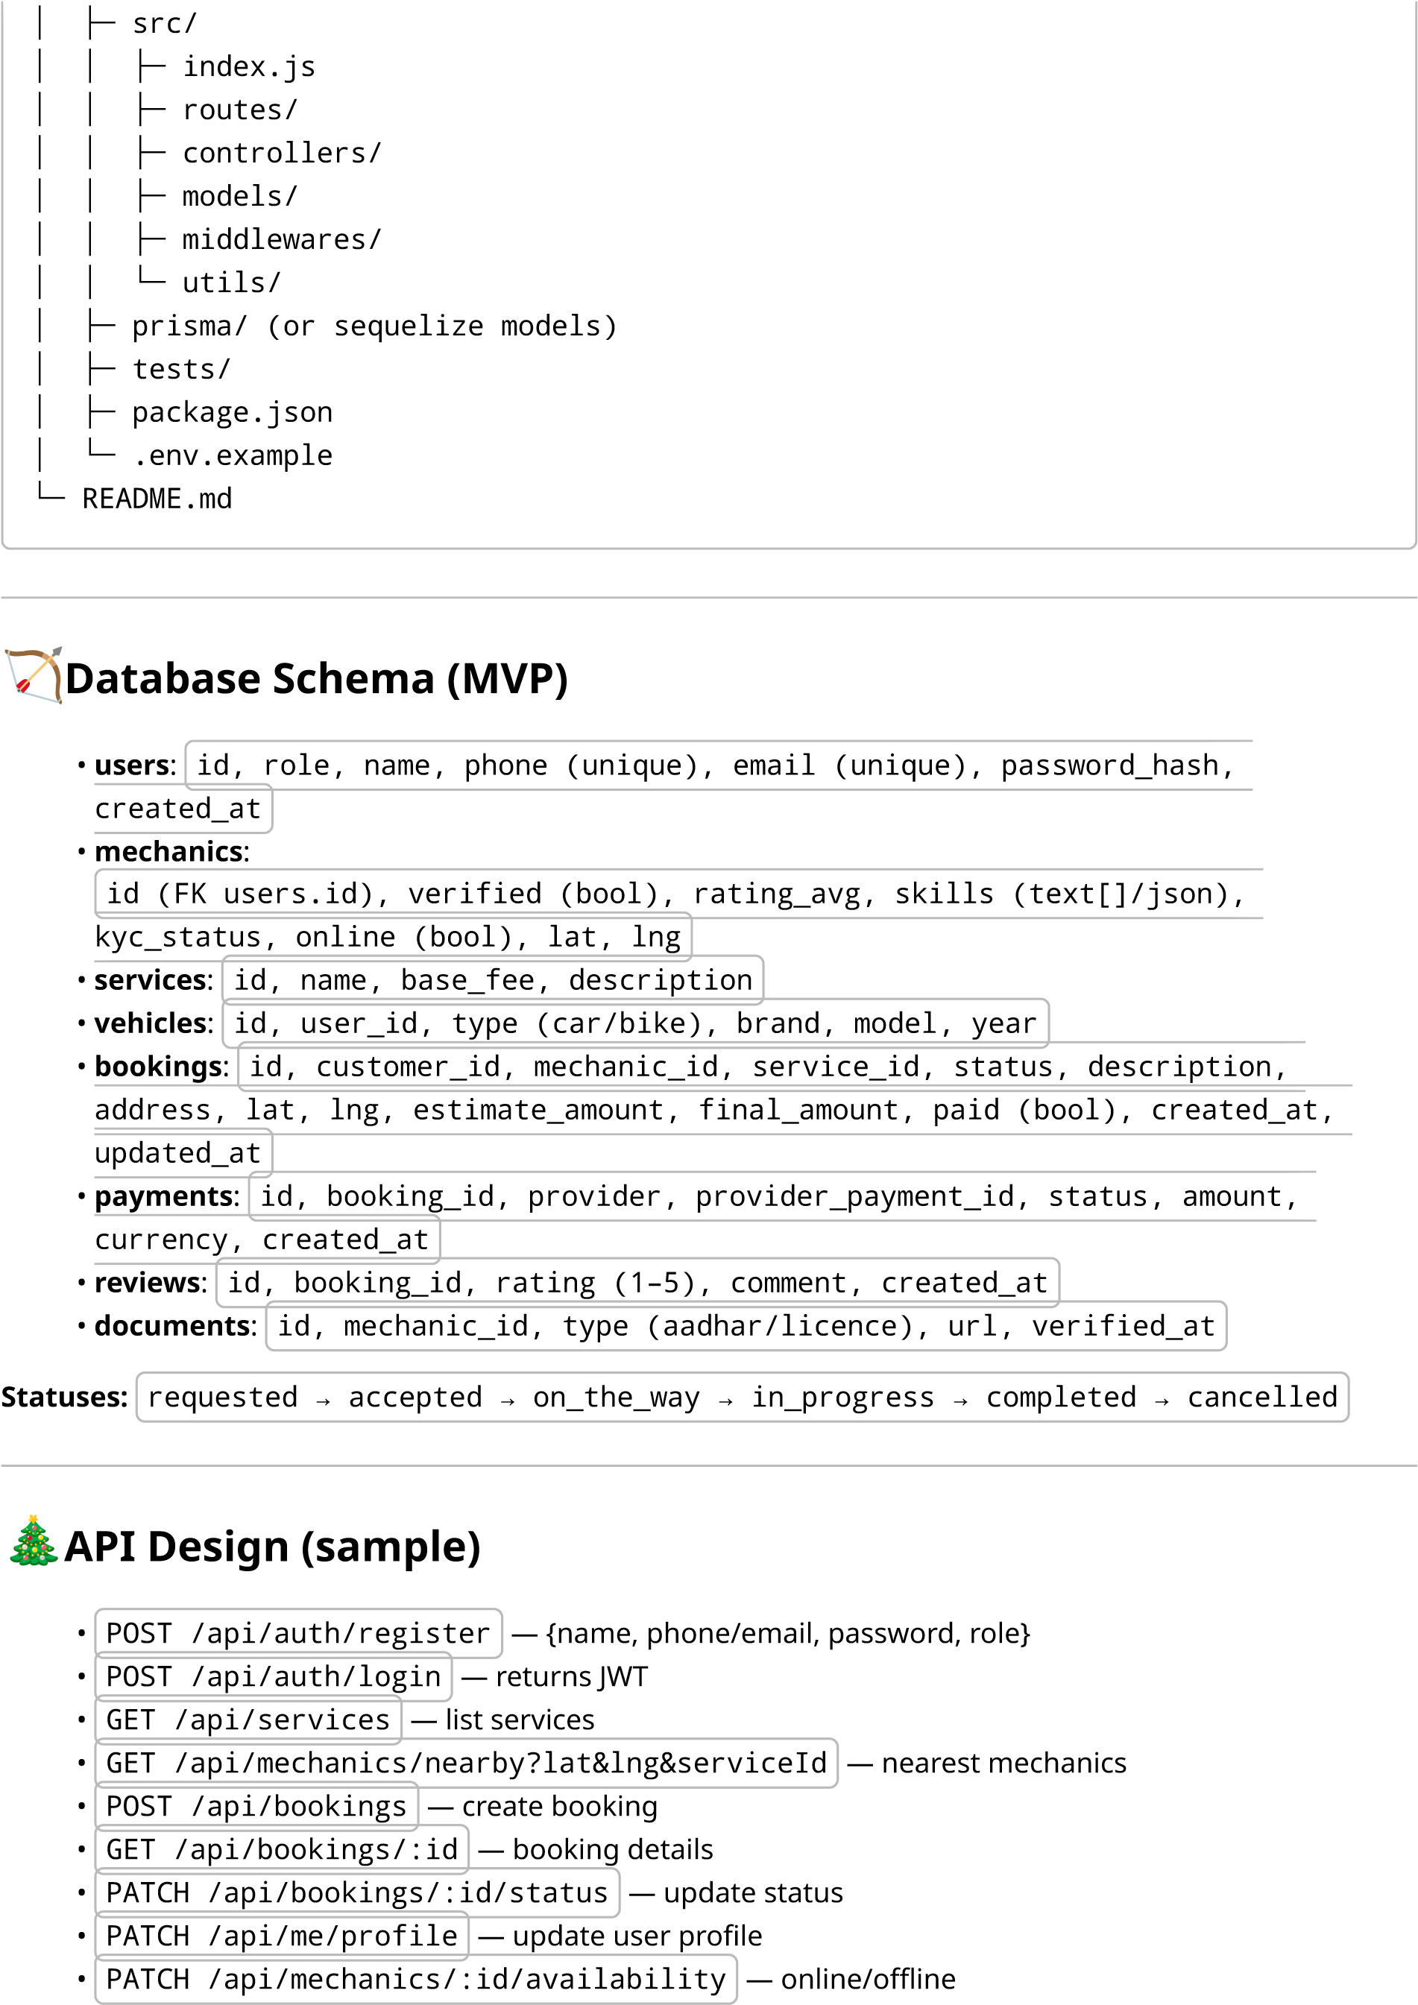
- POST /api/payments/create-order — create checkout order
- POST /api/webhooks/razorpay — verify capture (server‑to‑server)
WebSocket events: - booking:new , booking:update , mechanic:location , customer:location

🧩 Bootstrap UI Checklist
- Navbar ( .navbar , .navbar-expand-lg , .navbar-brand )
- Hero/Jumbotron ( .py-5 , .text-center , .btn.btn-primary )
- Service cards ( .card , .row.row-cols-1.row-cols-md-3.g-4 )
- Forms ( .form-control , .form-select , validation classes)
- Modals (login/register)
- Toasts/Alerts (status updates)
- Badges/Progress (booking status)
- Tables (admin)
- Spinners (loading states)

✅ Acceptance Criteria by Milestone
M1 (End of Week 1): Static responsive site with pages and working client‑side validation.
M2 (End of Week 3): Auth + CRUD bookings via API; mechanic can accept jobs; data in DB.
M3 (End of Week 5): Admin panel live; basic KYC toggle; lists & filters.
M4 (End of Week 7): Realtime status + payments integrated; receipts stored.
M5 (End of Week 8): Deployed with custom domain; E2E booking works publicly.
🧪
Testing Plan
- Unit/API: Jest + Supertest for routes/controllers
- E2E (UI): Playwright: book a service login as mechanic accept complete
• Security: Dependency audit, rate limit tests, JWT expiry tests
Load:
k6 for
POST /bookings
,
PATCH /status
🔐
Security & Privacy Basics
•
- Hash passwords (bcrypt), short‑lived JWTs, refresh tokens optional.
- Validate inputs (zod/joi) and sanitize outputs.
- Helmet + CORS; rate limiting on auth/booking endpoints.
- Store only needed PII; allow users to delete their account.
🚀
Deployment Checklist
- Env vars: DB_URL, JWT_SECRET, PAYMENT_KEYS, SMTP creds
- Build & deploy frontend + backend
- Migrations run; seed services
- Add monitoring, error tracking, daily DB backups

🧩 Starter Backlog (copy into your tracker)
- FE: Navbar + Hero + Services grid
- FE: Booking form + validation + estimate
- BE: Auth (register/login) + JWT middleware
- BE: Services CRUD + seed
- BE: Bookings create/read/update
- BE: Nearby mechanics (Haversine query)
- BE: Payments create order + webhook
- MECH: Dashboard accept/update status
- ADMIN: Verify mechanic + bookings table
- QA: Playwright E2E for full flow
📆
Week‑by‑Week Plan (12 weeks)
- W1: Phase 1 + start Phase 2
- W2: Finish Phase 2; begin Phase 3 (Auth + Services)
- W3: Bookings API + Mechanic availability; M2 demo
- W4: Mechanic dashboard UI; Admin skeleton
- W5: Admin functions; polish UX
- W6: Realtime status (Socket.io); start payments
- W7: Finish payments + receipts; harden errors/logs
- W8: Tests, docs, deploy (M5)
- W9: Feedback, fix, performance tweaks
- W10–W12: Enhancements (reviews, coupons, referrals, analytics)

🗣️ HOD Demo Script (2–3 minutes)
- Open Home Services Book fill form (shows estimate) pay (test mode).
- Switch to Mechanic Dashboard Accept Status progress Completed.
- Show Admin Panel Verify mechanic View booking record and payment status.

🔄 Next Optional Steps
- I can generate a Bootstrap starter homepage ( index.html , style.css , app.js ) you can run immediately.
- I can also provide a PostgreSQL schema + Prisma models and a basic Express server template.
Use this roadmap as your build checklist. Update it as you learn from your MVP launch.

